Matlab 1 - Report
Maria kholopova
e-mail: kholopovam@gmail.com

Table of Content
Call Price with Boundaries 2
Call Price as a function of S and T 5
Delta Call 6
Gamma Call 7
Vega Call 8
Theta Call 9
Implied interest rate from option prices 10
Analysis of the Volatility Smile 11
Publication bibliography 12
Declaration of Authorship 13

Call Price with Boundaries
On this graph, we see upper and lower arbitrage bounds for the value of a given call option.
The upper bound is our ex-dividend stock price: the value of a European call option does not exceed the value of the stock; our payoff ‘Stock price - Strike price’ cannot go higher than the stock price itself (Strike Price 0; Stock Price ∞).
The lower bound shows that the payoff cannot go below zero due to the simple reason that we have no incentive to exercise our option if the stock price is lower than the strike price, and the option is being left unexercised, with a zero payoff. This situation is reflected on the part of the graph where the stock price is in the following range: 0<Stock price<150, i.e. lower than the strike price. In general, a lower bound for a European call-option on stock with continuous dividends is represented by the price curve max(S e^{-qT} - X e^{-rT}, 0), where T is the time remaining until expiry (Hull 1993).
A European call must be worth at least the stock price (taken the continuous dividend effect in consideration) minus the discounted strike price; this lower bound assumes no volatility.
This price curve has two components: the intrinsic value of an option and the time value which depends on the remaining time to maturity, expected volatility and interest rate which represents either the cost of refinancing the underlying (as an alternative investment) or the interest income earned on reinvesting the differential between the underlying and call price (expected volatility is assumed to be zero). This lower bound gives an indication of how the time value of an option decreases with the decrease in time to maturity and therefore the price curve moves to the right. The intuitive explanation for this would be that longer-term calls have higher chances to end up in the money than shorter-term calls; therefore, they have higher value.
The slopes of the bounds are equal and are exp((h-r)*(T-t)). We have continuous dividends in our case, so h=r-q, where h-storage cost fund, r-interest rate and q-continuously paid dividends. This gives us the special case slope of exp((-q)*(T-t)), this value is lower than one which makes our bounds for option prices more flattened. The present value of the stock minus all future dividends received during the option lifetime is (let’s call it an ex-dividend stock price). The terminal distribution of the ex-dividend stock price determines the value of a call option. Our stock loses in value after the dividends payment; therefore its price drops and the value of corresponding European call options should also be lower if continuous dividends are paid. The European call’s terminal value on continuous dividend paying stocks is lower in comparison to calls on non-dividend paying stocks.
‘Continuous dividends’ is the BSM model assumption that dividends are paid continuously at a constant rate. The constant dividend yield model is held to be a good approximation for valuing index options like our DAX call option. DAX index have many stocks that pay dividends at many different times during an option’s lifetime. Our options are European style options, so the BSM option price formula can be applied. In general, for dividend-paying call options we see a difference between European and American call prices which are higher for American calls, due to higher call value since we are allowed to exercise an option earlier if it becomes optimal and benefit from the dividend payment.
As discussed before, with more time to maturity, time value of an option increases; so options with longer maturity are more expensive than ones with shorter maturity. However, in our special case of a call option on continuous dividend paying asset we see that for a call option with shorter maturities the slope of the bounds is bigger than for an option with longer maturities and so the terminal payoff is. Therefore, option with shorter maturity has a higher terminal value than the one with longer. This can be explained by the continuous dividend effect that decreases the option value the more time passes.
The difference between the bounds is the strike price of our option which determines the option’s intrinsic value. It shows the possible payoff of an option on the market with no arbitrage opportunities, i.e. arbitrage-free option price. No arbitrage opportunities would mean that an option is valued correctly by the market. If the market call price line is within the call price limits, along with the theoretical call price line then there are no arbitrage opportunities. For options with longer maturities, market call price should be closer to the option’s upper bound, with shorter time to maturity –closer to the option’s lower bound. This observation can be explained by the time value component of the option price (see the explanation above). Obviously, the same holds for the theoretical option price. Our graph proves this relationship.
The theoretical call price represents the closed form solution, i.e. the BSM formula. To create this line, we need to make a theoretical assumption about the possible volatility of the underlying which is assumed to be constant. BSM model assumptions are considered to be its major points of criticism. Therefore, it is not expected that market call price line would converge with the theoretical call price line (if we had such a line).
We can also observe that theoretical call price starts increasing toward 150 (“at the money” point) and after 150 it starts converging to the lower bound which is the option’s intrinsic value.
As a matter of fact, option prices change as the corresponding underlying price becomes closer or further to the exercise price. In general, the closer the option becomes to “at the money point” the more drastic the changes in its price are. Deep in the money or out of the money options do not show such sensitivity to the stock price changes. This observation is closely connected to the concept of implied volatility. Similarly, each strike price will respond differently to implied volatility changes. Options with strike prices that are near the money are most sensitive to implied volatility changes, while options that are further in the money or out of the money will be less sensitive to implied volatility changes (Kohler 2017).
Similar observations we can make when analyzing the 3-D graph “Call price as a function of S and T”.

Call Price as a function of S and T
Call price has the maximum reaction to the stock price “at the money position” but in general this reaction becomes less pronounced the longer time to maturity is. This is exactly what we can observe on the graph where an option with the shorter time to maturity shows strong reaction to the stock price changes at the money point. It starts increasing later at 150 and has a steeper slope. With the increase in time to maturity, the reaction is not that sharp and being spread over wider range of options’ strike prices (increases earlier (~100) but has a flatter slope). This call price behavior is usually explained by one of the Greeks – gamma (the speed of the call price change). It generally is at its peak value when the stock price is near the strike price of the option and decreases as the option goes deeper into or out of the money. As the time to expiration draws nearer, the gamma of at-the-money options increases while the gamma of in-the-money and out-of-the-money options decreases (“The Options Guide”, 2017). So, as we have seen for shorter maturities the change was significant for at-the-money options only, while for longer maturities more options showed higher reaction to stock prices changes already including in-the-money and out-of-the-money strike prices around at the money point; whereas at-the-money options showed relatively lower sensitivity than for shorter maturities.

Delta Call
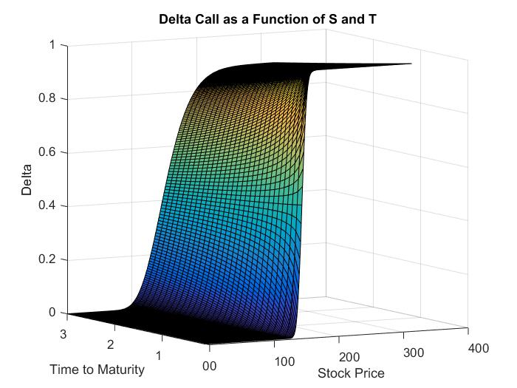
The Delta of an option measures the change in the value of the option for a corresponding change in the value of the underlying stock. (Chrostpher G. Deacon, Alex Faseruk 1999). The formula therefore is defined as the $∆=\frac{change in the value of the option}{change in the value of the underlying}$. In the following we’ll describe the change of delta for our Black-Scholes model from longer maturity to shorter maturity. The Delta is zero until shortly before the at the money point (X=150) for longer maturities. However, for shorter maturities it is visible that the graph starts to rise earlier and therefore closer to our X of 150. Furthermore, the graph shows that the slope starts relatively flat for the long maturity of 3 years and becomes steeper during the lifetime of the option and towards the maturity of 0. As for the previous point the graph has a lower maximum for longer times to maturity and constantly converges towards a Delta of 1 with shortening times to maturity. Through the steepening slope and the higher maximum towards shorter times to maturity we can deduce that the underlying stock affects the option price to a higher degree when the time to maturity (T) decreases.

Gamma Call
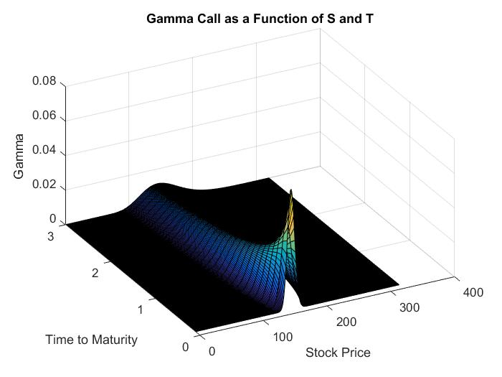
Hull defines the Gamma of an option as the: ”Rate of change of the portfolio’s delta with respect to the price of the underlying asset” (Hull 1993). Therefore, the Gamma is defined as the $Γ=\frac{change in the value of the option^{'}s delta}{change in the value of the underlying}$. As for the Delta, we’ll analyse the Gamma graph starting with the longer time to maturity until T=0. Since the Gamma is the first derivative of Delta it is logic that the graph rises earlier for longer times to maturity and increasingly late the shorter the maturities. The same can be observed for the slope of Gamma, which is relatively flat for long maturities until ~0.75 and then becomes extremely steep until the date of maturity. Gamma’s maximum also is lower for long maturities and extremely high for very short maturities but it can also be observed that the maximum lies in the money for longer times to maturities and converges towards the at the money point in time with shorter maturities until it is eventually directly above X=150. The increasing Gamma towards shorter maturities is a result of the strong reaction of Delta to changes in the price of the underlying. Furthermore, the maximum converges towards the at the money point because the Delta graph starts to rise later towards shorter maturities.

Vega Call
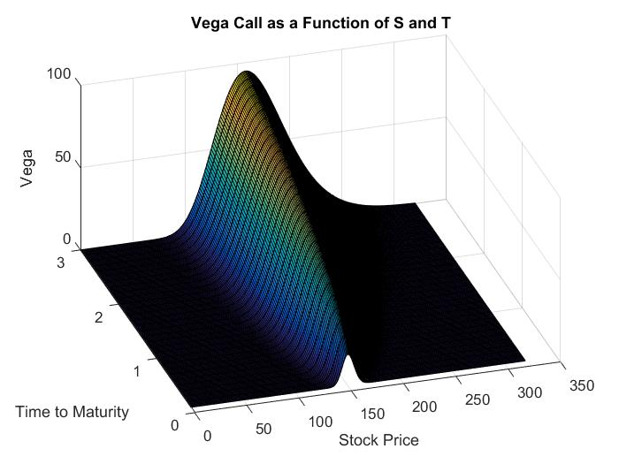
The Vega of a call option is defined as the “rate of change of the value of the portfolio with the respect to the volatility of the underlying asset.” (Hull 1993), where the formula can be defined as $∧=\frac{change in the value of the option}{change in the volatility}$. As for the previous Greeks, we’ll discuss the changes in Vega from the long time to maturity towards the maturity date. The Vega for long times to maturity starts to rise earlier than for short times to maturity. However, the maximum for longer times to maturity lies in the money whereas the maximum for shorter times to maturity is directly above the at the money point of X=150. Furthermore, Vega visibly decreases as the time to maturity decreases. We can therefore conclude that the sensitivity to changes in the volatility of the underlying are considerably higher for longer times to maturity than for shorter.

Theta Call
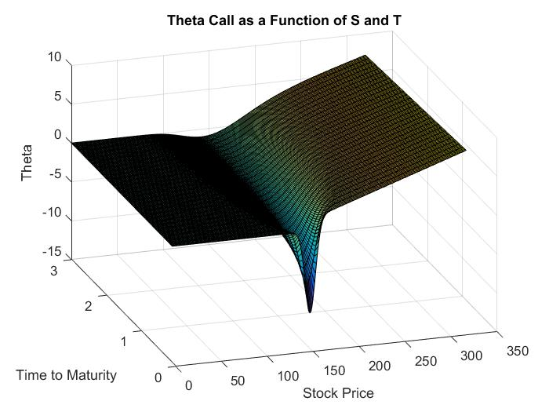
“The Theta of a portfolio of derivative securities, $Θ$, is the rate of change of the value of the portfolio with respect to time with all else remaining the same.” (Hull 1993). Therefore, it is defined as $Θ=\frac{change in value}{change in time}$. We’ll analyse the Theta starting with a time to maturity of 3 years towards a time of maturity of 0. In contrast to the other Greeks, the Theta of a European call option has a negative slope. However, the Theta for longer times to maturity starts to fall deeper in the out of the money area of the graph whereas as it starts to fall shortly before the at the money point for short times to maturity. The slope of the function is relatively flat for longer times to maturities and extremely steep for the maturity date and the short times to maturities (T<0.5 years). While the previous discussed Greeks all have maxima, the Theta has minima. The Theta graph has a relatively small minimum for longer times to maturity and an extreme minimum of ~ -10 for the date of maturity. The very steep slope and the extreme minimum for the very short times to maturities visualizes an extreme loss in the value of the option around the at the money point.

Implied interest rate from option prices
Initial data includes prices on DAX puts with expiration date in December 2016. Puts were traded on the April 14th, the estimated time to maturity is 0.6739726. We only took liquid puts which pricing would reflect the market conditions.
Our first step is to determine the implied interest rate from option prices: if you are a call buyer this is the interest rate you will be receiving from reinvesting the proceeds from short-selling the underlying. The basic equation for options arbitrage is:
Call Value = Intrinsic Value - Dividend Lost + Put Value + Interest
Why do we have an interest advantage? When investors buy calls instead of stock, they have extra cash (not used to buy stock) and that cash can earn interest. When rates are higher, they earn more interest, and thus, are willing to pay more to own call options. Moreover, they have interest savings from not having to borrow higher amount of money to buy an underlying than to buy calls.
From our point of view: Put Value = Intrinsic Value + Dividend Gain + Call Value – Interest Why do we have an interest disadvantage? Cash received by shorting stock can earn interest for the trader, while cash spent on buying puts is interest payable (assuming trader is borrowing money to buy puts). With an increase in interest rates, shorting stock becomes more profitable than buying puts, as the former generates income and the latter does the opposite.
The mean estimate of implied interest rates calculated from put-call parity appeared to be negative which reflects the existing market conditions at the time of trading transaction. However, this would mean that our discounted strike price would increase over time. The latter represents a contradiction in itself and destroys the whole principle of time value of money: this would mean that we have an opportunity to exercise our put as soon as we can and put the money in a risk-free security (so, we would not have to discount our strike price); but it is more than that: we would be able to do so at the very moment we hold a put. Thus, we cannot take a negative interest rate; we use an absolute value of this rate instead.
Analysis of the Volatility Smile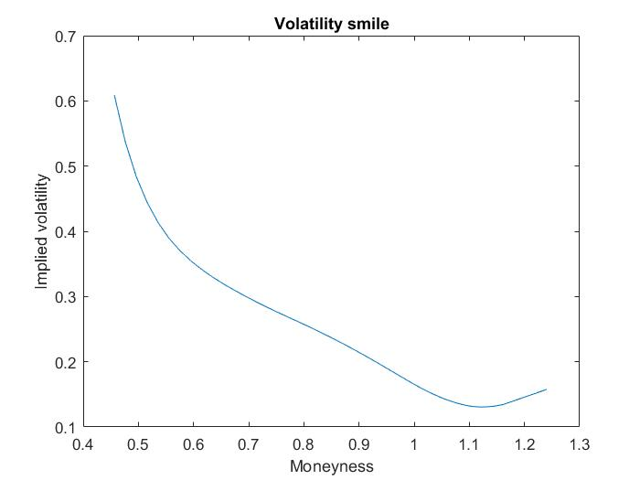
The graph above visualizes the implied volatility for the Dec. 2016 ODAX put. We will analyse the graph along the X-axis. The graph shows quite clearly that the volatility is very high (60%) for the out of the money strike price which in our case equals a moneyness of ~45%. The moneyness of a European put option is defined as: $M=\frac{X}{S}$. From the moneyness of ~45% until ~55% (deeply out of the money) the graph exhibits a very steep slope which means that the implied volatility in this area declines extremely. Around the moneyness of 55% the slope of the line starts to flatten. This is a result of the slower changing implied volatility of our put option. This flatter slope continuous throughout the at the money point (moneyness=100%) and into the in the money area. Then at a moneyness of ~110% the graph has a minimum and starts to increase. Therefore, we can conclude that the implied volatility of an option is the lowest shortly after the at the money point and increases the further we are in the out of the money or in the money area. As a result of this increase in volatility throughout the out of the money and in the money areas we obtain a typical reverse volatility skew. This implies that OTM put options are more expensive than the corresponding ITM call options. One possible explanation to the reverse volatility skew could be a phenomenon referred to as “crash-o-phobia” in (RUBINSTEIN 1994). It originates from the anxiety of the investors whereupon they buy put options to protect themselves from risk.
It is typical investor behaviour for the bearish market when PF insurance and ‘disaster hedge’ becomes popular and destabilizes the market; as a result implied volatility increases. Therefore, volatilities calculated from the deep OTM or ITM options deemed unreliable.
What exactly is happening? Higher demand for puts pumps up their price, which makes the volatility implied by those prices increase. In order for the put-call parity to hold and avoid arbitrage, puts and calls with the same strike prices must be traded at the same implied volatility level. Thus, calls with lower strike prices (ITM calls) have higher volatilities as well and their value increases (they are traded at higher bids then OTM calls).
We can also notice that our implied interest rates are not constant: as OTM put prices and volatilities increase implied interest rates adjust accordingly, i.e. they decrease (OTM put is worth more according to the market and therefore its implied interest rate should be lower, interest rate has a reverse relationship with the put value since cash paid for the option is interest-bearing). The OTM puts and ITM calls should also have the same implied interest rate; decrease in interest rate would decrease the value of a call (since in case of a call option we have interest earnings or savings); however, ITM calls are still more expensive than their OTM counterparts, which suggests that implied volatility effect is higher than the interest rate effect.
The Black-Scholes model assumes that volatility and interest rates are constant. As we have seen above it is not correct for real markets. We calculated implied volatilities from option prices across different strikes with the same time to maturity. What we observed is that they are not constant but a function of strike price that has a downward (skew) and upward (smile) slopes.
The volatility smile for equity options corresponds to the implied probability distribution (Hull 1993) which gives us higher probability of payoff for OTM puts than the lognormal distribution. According to implied distribution these options would be more expensive and have higher volatility which we could observe in reality (volatility smile).
The BSM model is an approximation of the reality; therefore, to get the correct price of an option, its value has to be adjusted. Thus, we get the “smiling” form of the graph. At the end of the day, market is a self-regulatory system which determines how much an option is worth, and thus the volatility and interest rate.

Publication bibliography
Chrostpher G. Deacon; Alex Faseruk (1999): AN EXAMINATION OF THE GREEKS (GREEK SYMBOLS) FROM THE BLACK SCHOLES OPTION 12 (1), pp. 50–58. Available online at http://www.redi-bw.de/db/ebsco.php/search.ebscohost.com/login.aspx%3fdirect%3dtrue%26db%3dbth%26AN%3d3987323%26site%3dehost-live, checked on 3/13/2017.
Di Mo; Todorova, Neda; Gupta, Rakesh (2015): Implied volatility smirk and future stock returns. Evidence from the German market. In Managerial Finance 41 (12), pp. 1357–1379. DOI: 10.1108/MF-04-2015-0097.
Etling, Cheri; Miller, Thomas W. (2000): The relationship between index option moneyness and relative liquidity. In J. Fut. Mark. 20 (10), pp. 971–987. DOI: 10.1002/1096-9934(200011)20:10<971::AID-FUT5>3.0.CO;2-8.
"Gamma." Gamma Explained | The Options & Futures Guide. N.p., n.d. Web. 25 Mar. 2017. Available online at http://www.theoptionsguide.com/gamma.aspx
Hull, John (1993): Options, futures, and other derivative securities. 2nd ed. Englewood Cliffs: Prentice Hall; London : Prentice-Hall International.
Kohler, Jeff. "Implied Volatility: Buy Low and Sell High." Investopedia. N.p., 15 Feb. 2017. Web. 25 Mar. 2017. Available online at http://www.investopedia.com/articles/optioninvestor/08/implied-volatility.asp
RUBINSTEIN, MARK (1994): Implied Binomial Trees. In The Journal of Finance 49 (3), pp. 771–818. DOI: 10.1111/j.1540-6261.1994.tb00079.x.

